**WooCommerce Connector Test Cases**

**Orders import process:**

1. Importing the WooCommerce orders into NetSuite. The NetSuite order data will contain the following information:
   * Customer (based on email Id)
   * Tax Amount
   * Shipping cost and Shipping method (shipping method will be set based on mapping in setup record)
   * Billing and shipping address
   * Payment method (payment method will be set based on mapping in setup record)
2. Importing the order with a discount: The WooCommerce order will be imported into NetSuite and set the discount item in the sales order line level to refer to the discount amount in WooCommerce.
3. Importing the order with eGift Card: -

* If the WooCommerce order contains an eGift Card purchase, the order will be imported into NetSuite. A non-inventory item will be set at the line level of the sales order to refer an eGift card.
* eGift Card redemption: If an eGift Card is used to place an order, the order will be imported into NetSuite, and the redemption amount will appear under the discount item in the sales order.

1. Updating order status: - when the order had been fully billed and fulfilled in NetSuite The order status will be updated to "Completed" in WooCommerce.
2. Refunds: - Once the cash sale record is created in the sales order, the connector will trigger the refunds in the WooCommerce.
3. Error Handling: - if connector was created the error record instated of the sales order

* Edit the error record and fix the error
* Please check “reprocess” check in the error record.
* Connector will create the sales order

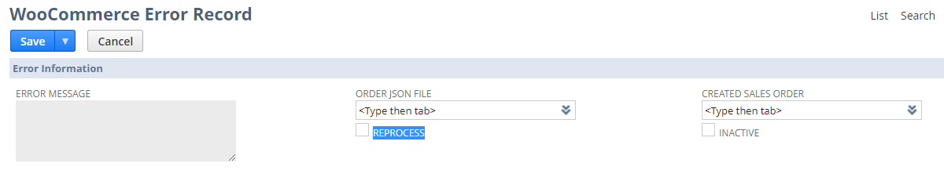

**Item Export/Update Process:**

1. To export the item from NetSuite to WooCommerce, please check the "Export To WooCommerce" check box in the item record. While exporting, the item price and quantity will update based on the below conditions.

* Regular price will update from the “Website” price level.
* Sales price will be update based on the sales Price (Checkbox), sales price start date and sales end date fields in the item record.
* Quantity will be updated from the sum of all locations with subtracting with buffer quantity. If the item was pre order item, quantity of the item will not be updated to WooCommerce.

1. To Update the item from NetSuite to WooCommerce, please check the “Update WooCommerce Product” checkbox in the item record
2. To Update price & inventory of the Item, please check the “Update Price & Inventory In WooCommerce” checkbox in the item record.